

**SOFTWARE TESTING Requirement Document**

**Trainer: Bharath**

**Email: Bharath.Nittech@Gmail.com**

**LinkedIn: https://www.linkedin.com/in/bharathnittech/**

**EPIC 1:**

**PAR-001 Home Page with login section to allow valid users to access the application**

**Epic Description:**

* **Para bank Logo should be there**
* **It should have Username, Password Textboxes and Login Button**
* **It should have option to reset the login information**
* **It should allow only registered users**
* **It should have option to register for new account**

**User story 1: Create/Setup application URL to launch login page**

**Description:**

Create/Setup application URL to launch login page

**Acceptance Criteria:**

* Setup URL to launch application: <https://parabank.parasoft.com/parabank/index.htm>
* User should be able to get login page with this URL
* User should be able to launch Para bank application without any issue in all types of browsers and all devices

**User story 2: Design customer login section**

**Description:**

All the fields should be available in the customer login section

**Acceptance Criteria:**

* Para bank Logo should be there at top centre in the Login page
* It should have Username, Password Textboxes and Login Button
* It should have forgot password option (Hyperlink)
* It should have option to create new account(Hyperlink)

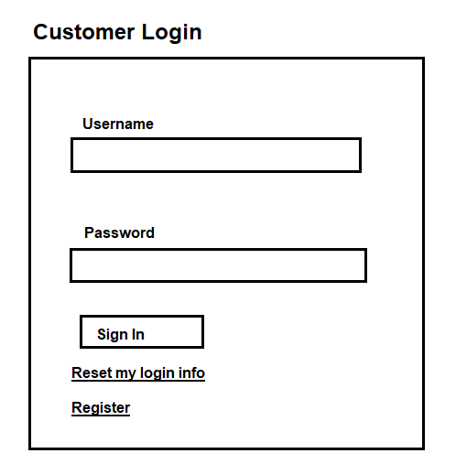

**User story 3: Verify login page validations**

**Description:**

Login page validations should be added to allow only valid users

**Acceptance Criteria:**

* Application should allow only registered users
* Sample User: nareshit , password: selenium
* When user login with valid credentials user should get account services page
* When user login with invalid credentials user should get error message ‘The username and password could not be verified’

**EPIC 2: PAR -002 Home Page to accommodate all application menus**

**Epic Description:**

Home Page should have multiple menus with all the relate information

1. Solutions

2. About Us

3. Services

4. Products

5. Locations

6. Admin Page

7. ATM Services

8. Online Services

9. Latest News

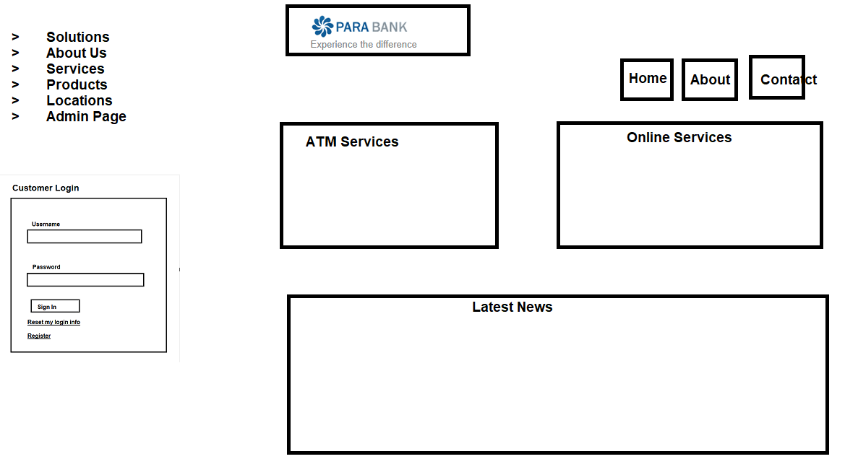

**User story 1: Add ATM Services in welcome page/Home Page**

**Description:**

Add ATM Services in welcome page

**Acceptance Criteria:**

* User should be able to see ATM services in Welcome page
* User should be able to see below sub menus
  + [Withdraw Funds](https://parabank.parasoft.com/parabank/services/ParaBank;jsessionid=ED583C6014F2311AE7C0D782AF198D96?wsdl)
  + [Transfer Funds](https://parabank.parasoft.com/parabank/services/ParaBank;jsessionid=ED583C6014F2311AE7C0D782AF198D96?wsdl)
  + [Check Balances](https://parabank.parasoft.com/parabank/services/ParaBank;jsessionid=ED583C6014F2311AE7C0D782AF198D96?wsdl)
  + [Make Deposits](https://parabank.parasoft.com/parabank/services/ParaBank;jsessionid=ED583C6014F2311AE7C0D782AF198D96?wsdl)
* User should be able to access all the ATM Services
* When User click on the link it should navigate to the respective service page
* Beside ATM services ‘picture’ should be there with ATM Machine along with ATM card



**User story 2: Add Online Services in welcome page/Home Page**

**Description:**

Add Online Services in welcome page

**Acceptance Criteria:**

* User should be able to see Online Services in Welcome page
* User should be able to see below sub menus
  + [Bill](https://parabank.parasoft.com/parabank/services/ParaBank;jsessionid=ED583C6014F2311AE7C0D782AF198D96?wsdl) Pay
  + Account History
  + Transfer Funds
* User should be able to access all the Online Services
* When User click on the link it should navigate to the respective service page

**User story 3: Add Latest News section in welcome page/Home Page**

**Description:**

Add Latest news section in welcome page

**Acceptance Criteria:**

* User should be able to see Latest news section in Welcome page
* User should be able to see today’s date in the section
* User should be able to see all the news related to Para bank in this section
* User should be able to access all the news links
* Beside Latest news links ‘picture’ should be there with the text LATEST NEWS



**User story 4: Add Para bank info menus in welcome page/Home Page**

**Description:**

Add Para bank info menus in welcome page

**Acceptance Criteria:**

* User should be able to see below menus in Welcome page
  + Solutions
  + [About Us](https://parabank.parasoft.com/parabank/about.htm;jsessionid=ED583C6014F2311AE7C0D782AF198D96)
  + [Services](https://parabank.parasoft.com/parabank/services.htm;jsessionid=ED583C6014F2311AE7C0D782AF198D96)
  + [Products](http://www.parasoft.com/jsp/products.jsp)
  + [Locations](http://www.parasoft.com/jsp/pr/contacts.jsp)
  + [Admin Page](https://parabank.parasoft.com/parabank/admin.htm;jsessionid=ED583C6014F2311AE7C0D782AF198D96)
* User should be able to access all the application menu links without any error

**User story 5: Add Para bank header and app menu icons in welcome page/Home Page**

**Description:**

Add Para bank header and app menu icons in welcome page/Home Page

**Acceptance Criteria:**

* User should be able to see application header in the home page as ‘Welcome to Parabank’
* User should be able to see below 3 icons below the header
  + Home
  + About
  + Contact Us

**User story 6: Add Para bank info menus and copy rights information at the bottom of welcome page/Home Page**

**Description:**

Add Para bank info menus and copy rights information at the bottom of welcome page/Home Page

**Acceptance Criteria:**

* User should be able to see below menus at the bottom of welcome page
  + Home
  + [About Us](https://parabank.parasoft.com/parabank/about.htm;jsessionid=ED583C6014F2311AE7C0D782AF198D96)
  + [Services](https://parabank.parasoft.com/parabank/services.htm;jsessionid=ED583C6014F2311AE7C0D782AF198D96)
  + [Products](http://www.parasoft.com/jsp/products.jsp)
  + [Locations](http://www.parasoft.com/jsp/pr/contacts.jsp)
  + [Forum](https://parabank.parasoft.com/parabank/admin.htm;jsessionid=ED583C6014F2311AE7C0D782AF198D96)
  + Site Map
  + Contact Us
* User should be able to access all the application menu links without any error
* Below these links user should be able to see copy rights information
  + © Parasoft. All rights reserved.
  + Visit us at: www.parasoft.com

**Epic 3: PAR -003 Forgot Password Page to reset the password**

**Epic Description:**

Forgot password page should have texts field to update customer information and reset the password

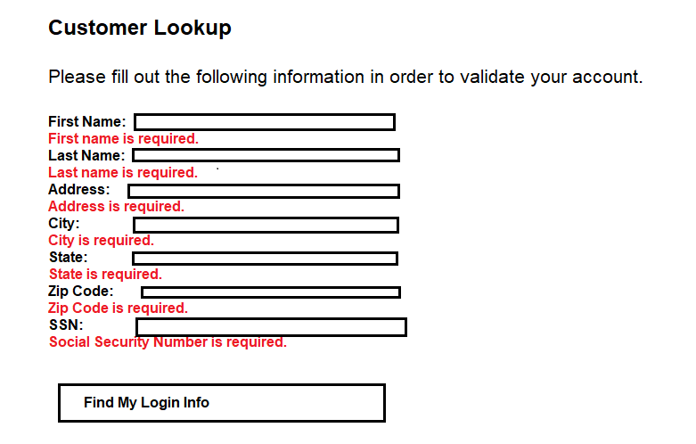

**User story 1: Build forgot password page to reset the password**

**Description:**

Build forgot password page in Para bank application to reset the password

**Acceptance Criteria:**

* User should have option to reset the password in Login page
* Once user click on reset password it should navigate to forgot password page
* Forgot password page header should be ‘Customer Lookup’
* Add message below header ‘Please fill out the following information in order to validate your account.’
* User should have below text boxes
  + First Name:
  + Last Name:
  + Address:
  + City:
  + State:
  + Zip Code:
  + SSN:
* User should have ‘Find My login info’ button

**User story 2: Forgot password page field validations**

**Description:**

User should get error message when there is no value entered

**Acceptance Criteria:**

User should get below error messages in red colour when user is trying to click on ‘FIND MY LOGIN INFO’ button without updating values in customer info fields

First Name:

First name is required.

Last Name:

Last name is required.

Address:

Address is required.

City:

City is required.

State:

State is required.

Zip Code:

Zip Code is required.

SSN:

Social Security Number is required.

|  |  |  |
| --- | --- | --- |
| **First Name:** |  | First name is required. |
| **Last Name:** |  | Last name is required. |
| **Address:** |  | Address is required. |
| **City:** |  | City is required. |
| **State:** |  | State is required. |
| **Zip Code:** |  | Zip Code is required. |
| **SSN:** |  | Social Security Number is required. |

**EPIC 4 : PAR -004 Registration page to sign-up for new account**

**Epic Description:**

Registration page should have valid fields to collect customer information and user should be able to create new account

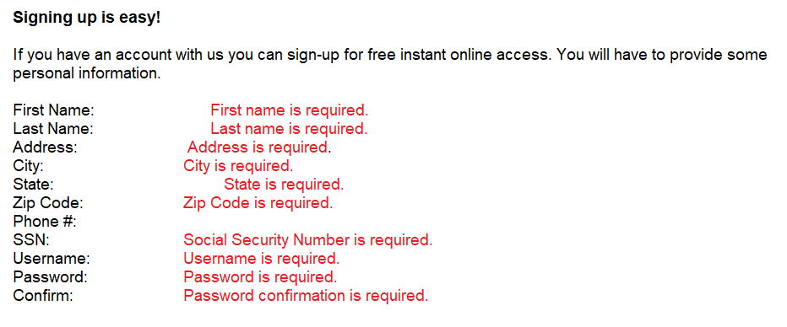

**User story 1: Build registration page to create new account**

**Description:**

Build registration page in Para bank application to create new account

**Acceptance Criteria:**

* User should have option to register in Login page
* Once user click on register button it should navigate to registration page
* Registration page header should be ‘Signing up is easy!’
* Add message below header ‘If you have an account with us you can sign-up for free instant online access. You will have to provide some personal information.’
* User should have below text boxes
  + First Name:
  + Last Name:
  + Address:
  + City:
  + State:
  + Zip Code:
  + Phone #:
  + SSN:
  + Username:
  + Password:
  + Confirm:

* User should have ‘REGISTER’ button

**User story 2: Registration page field validations**

**Description:**

User should get error message when there is missing value in registration page

**Acceptance Criteria:**

User should get below error messages in red colour when user is trying to click on ‘REGISTER’ button without updating values in registration page fields

First Name:

First name is required.

Last Name:

Last name is required.

Address:

Address is required.

City:

City is required.

State:

State is required.

Zip Code:

Zip Code is required.

Phone #:

SSN:

Social Security Number is required.

Username:

Username is required.

Password:

Password is required.

Confirm:

Password confirmation is required.

**EPIC 5: PAR-005 New account opening page**

**Epic Description:**

User should have options to open new saving account and checking accounts in new account opening page

Valid account number should be generated for each account

Minimum 100$ should be deposited in each account while opening the new account

**User story 1: Build new account opening page**

**Description:**

User should get account opening page to open new account

**Acceptance Criteria:**

* User should have option ‘Open New Account’ to open new account in welcome page after login with valid credentials
* Page header should be ‘Open New Account’
* User should have options to create ‘Checking’ and ‘Savings’ account
* Default account type should be ‘SAVINGS’
* User should have button ‘Open new Account’

**User story 2: Build new Checking/Savings account Feature**

**Description:**

User should be able to create new bank accounts

**Acceptance Criteria:**

* User should have option ‘Open New Account’ to open new account in welcome page after login with valid credentials
* User should have options to create ‘Checking’ and ‘Savings’ account
* Once user selects the account type and click on ‘Open new Account’ button user should get new account number with below messages
  + Account Opened! (Header)
  + Congratulations, your account is now open. (Message)
  + Your new account number: ****** (Account info)
* New Account should be deposited with 100 $

**EPIC 6: PAR-006 Account overview page to get customer account information**

**Epic Description:**

User should have options to check all the accounts information and transaction details from Account overview page

**User story 1: Create account overview page with all account details for the customer**

**Description:**

Create account overview page with all account details for the customer

**Acceptance Criteria:**

* User should have option ‘Account Overview’ to check all customer account details in the welcome page after login with valid credentials
* Page header should be ‘Account Overview’
* User should be able to see all accounts, Balance and available amount
* User should get total available amount of all accounts

**User story 2: Create account transactions page with all transaction’s details of each account**

**Description:**

Create account transactions page with all transaction’s details of each account

**Acceptance Criteria:**

* User should have option ‘Account Overview’ to check all customer account details in the welcome page after login with valid credentials
* Page header should be ‘Account Overview’
* User should be able to see all accounts, Balance and available amount
* Once user click on account number user should get complete transactions related to particular account